**1. Каждый месяц компания выдает премию в размере 5% от суммы продаж менеджеру, который за предыдущие 3 месяца продал товаров на самую большую сумму**

**Выведите месяц, manager_id, manager_first_name, manager_last_name, премию за период с января по декабрь 2014 года**

WITH monthly_sales AS (

SELECT

date_trunc('month', sale_date) AS sale_month,

manager_id,

manager_first_name,

manager_last_name,

SUM(sale_amount) AS total_sales

FROM

public.v_fact_sale

WHERE

sale_date BETWEEN to_date('2013-10-01', 'YYYY-MM-DD') AND to_date('2014-12-31', 'YYYY-MM-DD')

GROUP BY

sale_month, manager_id, manager_first_name, manager_last_name

),

three_month_sales AS (

SELECT

sale_month,

manager_id,

manager_first_name,

manager_last_name,

SUM(total_sales) OVER (

PARTITION BY manager_id

ORDER BY sale_month

ROWS BETWEEN 2 PRECEDING AND CURRENT ROW

) AS three_month_sales

FROM

monthly_sales

)

SELECT

to_char(sale_month, 'YYYY-MM') AS month,

manager_id,

manager_first_name,

manager_last_name,

ROUND(three_month_sales * 0.05, 2) AS bonus

FROM (

SELECT

sale_month,

manager_id,

manager_first_name,

manager_last_name,

three_month_sales,

RANK() OVER (PARTITION BY sale_month ORDER BY three_month_sales DESC) AS rank

FROM

three_month_sales

) AS ranked_sales

WHERE

rank = 1

AND sale_month BETWEEN to_date('2014-01-01', 'YYYY-MM-DD') AND to_date('2014-12-31', 'YYYY-MM-DD')

ORDER BY

month; WITH monthly_sales AS (

SELECT

date_trunc('month', sale_date) AS sale_month,

manager_id,

manager_first_name,

manager_last_name,

SUM(sale_amount) AS total_sales

FROM

public.v_fact_sale

WHERE

sale_date BETWEEN to_date('2013-10-01', 'YYYY-MM-DD') AND to_date('2014-12-31', 'YYYY-MM-DD')

GROUP BY

sale_month, manager_id, manager_first_name, manager_last_name

),

three_month_sales AS (

SELECT

sale_month,

manager_id,

manager_first_name,

manager_last_name,

SUM(total_sales) OVER (

PARTITION BY manager_id

ORDER BY sale_month

ROWS BETWEEN 2 PRECEDING AND CURRENT ROW

) AS three_month_sales

FROM

monthly_sales

)

SELECT

to_char(sale_month, 'YYYY-MM') AS month,

manager_id,

manager_first_name,

manager_last_name,

ROUND(three_month_sales * 0.05, 2) AS bonus

FROM (

SELECT

sale_month,

manager_id,

manager_first_name,

manager_last_name,

three_month_sales,

RANK() OVER (PARTITION BY sale_month ORDER BY three_month_sales DESC) AS rank

FROM

three_month_sales

) AS ranked_sales

WHERE

rank = 1

AND sale_month BETWEEN to_date('2014-01-01', 'YYYY-MM-DD') AND to_date('2014-12-31', 'YYYY-MM-DD')

ORDER BY

month;

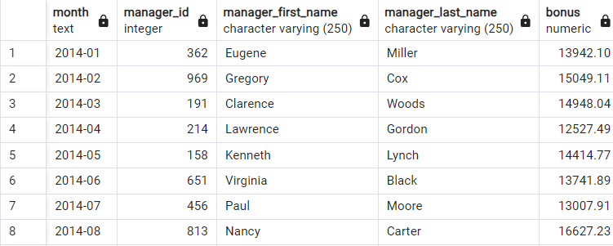

**2. Компания хочет оптимизировать количество офисов, проанализировав относительные объемы продаж по офисам в течение периода с 2013-2014 гг.**

**Выведите год, office_id, city_name, country, относительный объем продаж за текущий год**

**Офисы, которые демонстрируют наименьший относительной объем в течение двух лет скорее всего будут закрыты.**

SELECT

EXTRACT(YEAR FROM sale_date) AS year,

office_id,

city_name,

country,

SUM(sale_amount) / SUM(SUM(sale_amount)) OVER (PARTITION BY EXTRACT(YEAR FROM sale_date)) AS relative_sales_share

FROM

public.v_fact_sale

WHERE

sale_date BETWEEN TO_DATE('2013-01-01', 'YYYY-MM-DD') AND TO_DATE('2014-12-31', 'YYYY-MM-DD')

GROUP BY

year, office_id, city_name, country

ORDER BY

year, relative_sales_share;

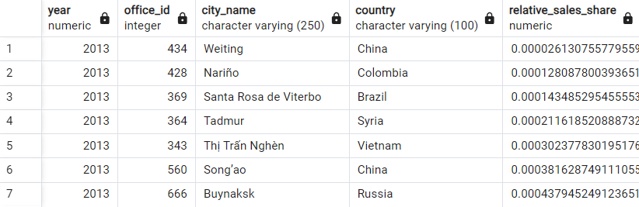

**3. Для планирования закупок, компанию оценивает динамику роста продаж по товарам.**

**Динамика оценивается как отношение объема продаж в текущем месяце к предыдущему.**

**Выведите товары, которые демонстрировали наиболее высокие темпы роста продаж в течение первого полугодия 2014 года.**

WITH monthly_sales AS (

SELECT

product_id,

product_name,

DATE_TRUNC('month', sale_date) AS sale_month,

SUM(sale_qty) AS total_sales_qty

FROM

public.v_fact_sale

WHERE

sale_date BETWEEN TO_DATE('2014-01-01', 'YYYY-MM-DD') AND TO_DATE('2014-06-30', 'YYYY-MM-DD')

GROUP BY

product_id, product_name, sale_month

),

growth_rate AS (

SELECT

ms1.product_id,

ms1.product_name,

ms1.sale_month,

ms1.total_sales_qty,

COALESCE(

ROUND(CAST(ms1.total_sales_qty AS NUMERIC) / NULLIF(ms2.total_sales_qty, 0), 2),

0

) AS growth_rate

FROM

monthly_sales ms1

LEFT JOIN

monthly_sales ms2

ON ms1.product_id = ms2.product_id

AND ms1.sale_month = ms2.sale_month + INTERVAL '1 month'

)

SELECT

product_id,

product_name,

sale_month,

growth_rate

FROM

growth_rate

ORDER BY

growth_rate DESC, product_id, sale_month;

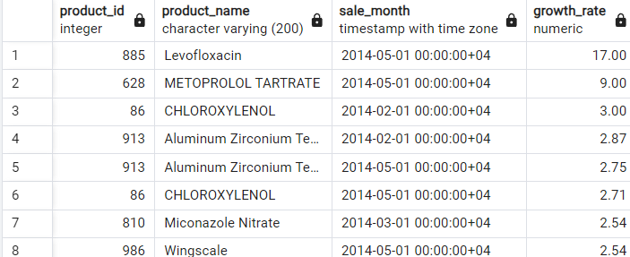

**4. Напишите запрос, который выводит отчет о прибыли компании за 2014 год: помесячно и поквартально.**

**Отчет включает сумму прибыли за период и накопительную сумму прибыли с начала года по текущий период.**

WITH monthly_sales AS (

SELECT

DATE_TRUNC('month', sale_date) AS month,

SUM(sale_amount) AS sales_amount,

SUM(sale_amount * 0.90) AS cost_amount -- 90% от суммы продаж для расчета исходной стоимости (10% наценка)

FROM

public.v_fact_sale

WHERE

sale_date BETWEEN TO_DATE('2014-01-01', 'YYYY-MM-DD') AND TO_DATE('2014-12-31', 'YYYY-MM-DD')

GROUP BY

DATE_TRUNC('month', sale_date)

),

monthly_profit AS (

SELECT

month,

(sales_amount - cost_amount) AS profit_amount

FROM

monthly_sales

),

quarterly_profit AS (

SELECT

DATE_TRUNC('quarter', month) AS quarter,

SUM(profit_amount) AS quarterly_profit_amount

FROM

monthly_profit

GROUP BY

DATE_TRUNC('quarter', month)

),

cumulative_profit AS (

SELECT

month,

profit_amount,

SUM(profit_amount) OVER (ORDER BY month) AS cumulative_profit_amount

FROM

monthly_profit

UNION ALL

SELECT

quarter AS month,

quarterly_profit_amount AS profit_amount,

SUM(quarterly_profit_amount) OVER (ORDER BY quarter) AS cumulative_profit_amount

FROM

quarterly_profit

)

SELECT

month,

profit_amount,

cumulative_profit_amount

FROM

cumulative_profit

ORDER BY

month;

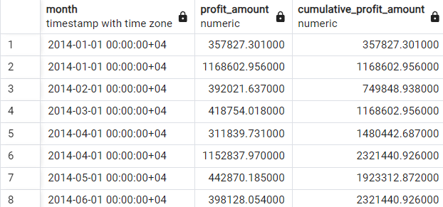

**5. Найдите вклад в общую прибыль за 2014 год 10% наиболее дорогих товаров и 10% наиболее дешевых товаров.**

Выведите product_id, product_name, total_sale_amount, percent

WITH product_prices AS (

SELECT

product_id,

product_name,

AVG(sale_price) AS avg_price

FROM

public.v_fact_sale

WHERE

sale_date BETWEEN TO_DATE('2014-01-01', 'YYYY-MM-DD') AND TO_DATE('2014-12-31', 'YYYY-MM-DD')

GROUP BY

product_id, product_name

),

ranked_products AS (

SELECT

product_id,

product_name,

avg_price,

NTILE(10) OVER (ORDER BY avg_price DESC) AS price_decile

FROM

product_prices

),

top_10_percent AS (

SELECT

rp.product_id,

rp.product_name,

SUM(vfs.sale_amount) AS total_sale_amount

FROM

ranked_products rp

JOIN

public.v_fact_sale vfs ON rp.product_id = vfs.product_id

WHERE

rp.price_decile = 1

AND vfs.sale_date BETWEEN TO_DATE('2014-01-01', 'YYYY-MM-DD') AND TO_DATE('2014-12-31', 'YYYY-MM-DD')

GROUP BY

rp.product_id, rp.product_name

),

bottom_10_percent AS (

SELECT

rp.product_id,

rp.product_name,

SUM(vfs.sale_amount) AS total_sale_amount

FROM

ranked_products rp

JOIN

public.v_fact_sale vfs ON rp.product_id = vfs.product_id

WHERE

rp.price_decile = 10

AND vfs.sale_date BETWEEN TO_DATE('2014-01-01', 'YYYY-MM-DD') AND TO_DATE('2014-12-31', 'YYYY-MM-DD')

GROUP BY

rp.product_id, rp.product_name

),

total_profit_2014 AS (

SELECT

SUM(sale_amount) AS total_sale_amount

FROM

public.v_fact_sale

WHERE

sale_date BETWEEN TO_DATE('2014-01-01', 'YYYY-MM-DD') AND TO_DATE('2014-12-31', 'YYYY-MM-DD')

)

SELECT

pd.product_id,

pd.product_name,

pd.total_sale_amount,

ROUND((pd.total_sale_amount / tp.total_sale_amount) * 100, 2) AS percent

FROM (

SELECT * FROM top_10_percent

UNION ALL

SELECT * FROM bottom_10_percent

) AS pd, total_profit_2014 tp

ORDER BY

percent DESC;

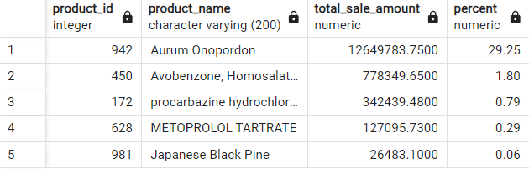

**6. Компания хочет премировать трех наиболее продуктивных (по объему продаж, конечно) менеджеров в каждой стране в 2014 году.**

**Выведите country, <список manager_last_name manager_first_name, разделенный запятыми> которым будет выплачена премия**

WITH manager_sales AS (

SELECT

country,

manager_id,

manager_last_name,

manager_first_name,

SUM(sale_qty) AS total_sales_qty

FROM

public.v_fact_sale

WHERE

sale_date BETWEEN TO_DATE('2014-01-01', 'YYYY-MM-DD') AND TO_DATE('2014-12-31', 'YYYY-MM-DD')

GROUP BY

country, manager_id, manager_last_name, manager_first_name

),

top_managers AS (

SELECT

country,

manager_id,

manager_last_name,

manager_first_name,

total_sales_qty,

ROW_NUMBER() OVER (PARTITION BY country ORDER BY total_sales_qty DESC) AS sales_rank

FROM

manager_sales

)

SELECT

country,

STRING_AGG(manager_last_name || ' ' || manager_first_name, ', ') AS top_managers

FROM

top_managers

WHERE

sales_rank <= 3

GROUP BY

country

ORDER BY

country;

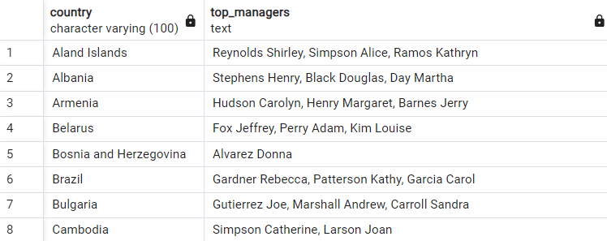

**7. Выведите самый дешевый и самый дорогой товар, проданный за каждый месяц в течение 2014 года.**

**cheapest_product_id, cheapest_product_name, expensive_product_id, expensive_product_name, month, cheapest_price, expensive_price**

WITH monthly_product_sales AS (

SELECT

DATE_TRUNC('month', sale_date) AS sale_month,

product_id,

product_name,

MIN(sale_price) AS min_price,

MAX(sale_price) AS max_price

FROM

public.v_fact_sale

WHERE

sale_date BETWEEN TO_DATE('2014-01-01', 'YYYY-MM-DD') AND TO_DATE('2014-12-31', 'YYYY-MM-DD')

GROUP BY

sale_month, product_id, product_name

),

cheapest_products AS (

SELECT DISTINCT ON (sale_month)

sale_month AS month,

product_id AS cheapest_product_id,

product_name AS cheapest_product_name,

min_price AS cheapest_price

FROM

monthly_product_sales

ORDER BY

sale_month, min_price ASC

),

expensive_products AS (

SELECT DISTINCT ON (sale_month)

sale_month AS month,

product_id AS expensive_product_id,

product_name AS expensive_product_name,

max_price AS expensive_price

FROM

monthly_product_sales

ORDER BY

sale_month, max_price DESC

)

SELECT

cp.month,

cp.cheapest_product_id,

cp.cheapest_product_name,

cp.cheapest_price,

ep.expensive_product_id,

ep.expensive_product_name,

ep.expensive_price

FROM

cheapest_products cp

JOIN

expensive_products ep ON cp.month = ep.month

ORDER BY

cp.month;

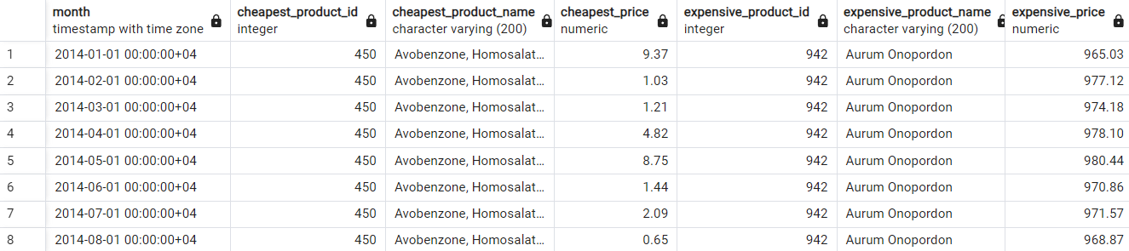

**8. Менеджер получает оклад в 30 000 + 5% от суммы своих продаж в месяц. Средняя наценка стоимости товара - 10%**

**Посчитайте прибыль предприятия за 2014 год по месяцам (сумма продаж - (исходная стоимость товаров + зарплата))**

month, sales_amount, salary_amount, profit_amount

WITH monthly_sales AS (

SELECT

DATE_TRUNC('month', sale_date) AS month,

SUM(sale_amount) AS sales_amount,

SUM(sale_amount * 0.90) AS cost_amount -- 90% от суммы продаж для расчета исходной стоимости (10% наценка)

FROM

public.v_fact_sale

WHERE

sale_date BETWEEN TO_DATE('2014-01-01', 'YYYY-MM-DD') AND TO_DATE('2014-12-31', 'YYYY-MM-DD')

GROUP BY

DATE_TRUNC('month', sale_date)

),

monthly_salary AS (

SELECT

month,

sales_amount,

cost_amount,

30000 + (sales_amount * 0.05) AS salary_amount -- Оклад + 5% от продаж

FROM

monthly_sales

)

SELECT

ms.month,

ms.sales_amount,

ms.salary_amount,

ms.sales_amount - (ms.cost_amount + ms.salary_amount) AS profit_amount -- Прибыль = продажа - (стоимость + зарплата)

FROM

monthly_salary ms

ORDER BY

ms.month;

